 | SPECIAL EVENT PERMIT TO USE OR OCCUPY A HIGHWAY OR HIGHWAY RIGHT-OF-WAY
Instructions and Insurance Provisions for H0021-SE Application Form

SPECIAL EVENT PERMIT INSURANCE AND TRAFFIC MANAGEMENT INSTRUCTIONS

1. Consult the ‘Special Events: Third-Party (CGL) Risk, Insurance and Traffic Management Matrix’ on page 2 of this form to determine whether the Low Risk, Medium Risk, High Risk, or Extreme Risk category applies to the Special Event.
2. Choose the appropriate Traffic Management plan in the
4 drop downs in Section 8 of the permit (H0021-SE).
Link to 2020 Traffic Management Manual for Work on Roadways:
https://www2.gov.bc.ca/assets/gov/driving-and-transportation/transportation-infrastructure/engineering-standards-and-guidelines/traffic-engineering-and-safety/traffic-engineering/traffic-management-and-traffic-control/2020-traffic-control-manual/2020-traffic-management-manual-for-work-on-roadways.pdf
3. IF the permit requires a Traffic Management Plan (Section 8), attach the ‘Special Events Traffic Control Template’ (Page 3 of this form) as an Appendix.
IF the permit requires other traffic operational requirements, attach the ‘Traffic Operational Requirements’ (page 4 of this form) as an Appendix.
4. Copy and paste the appropriate Insurance clauses
from the options on pages 5 and 6 of this form into
Section 16 of the permit (H0021-SE).
REMINDER: If your Special Event falls in the Extreme Risk Category, contact Insurance and Bonds.
Questions Traffic Management:
Email: MoTITMM@gov.bc.ca
Insurance:
Email: INSURANCEandBONDS@gov.bc.ca
(250) 356-9774
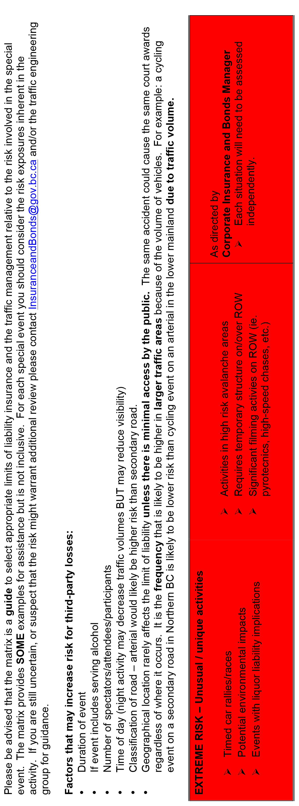
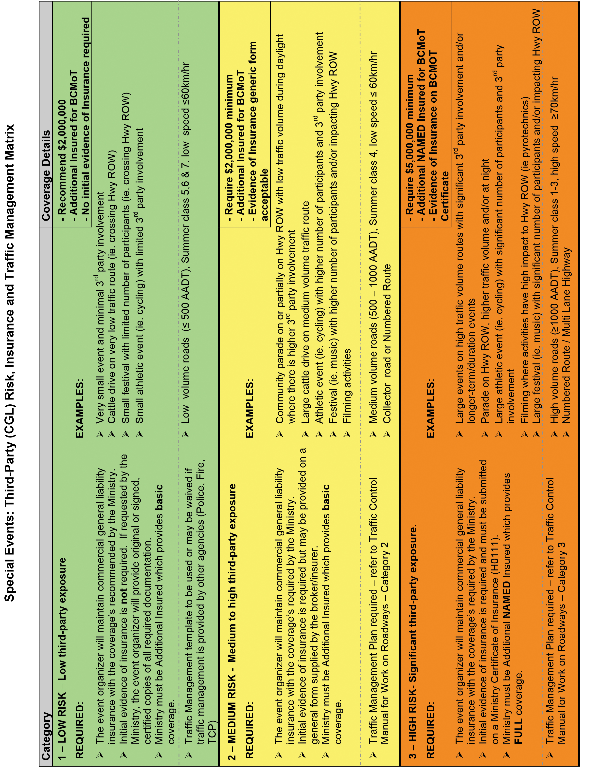

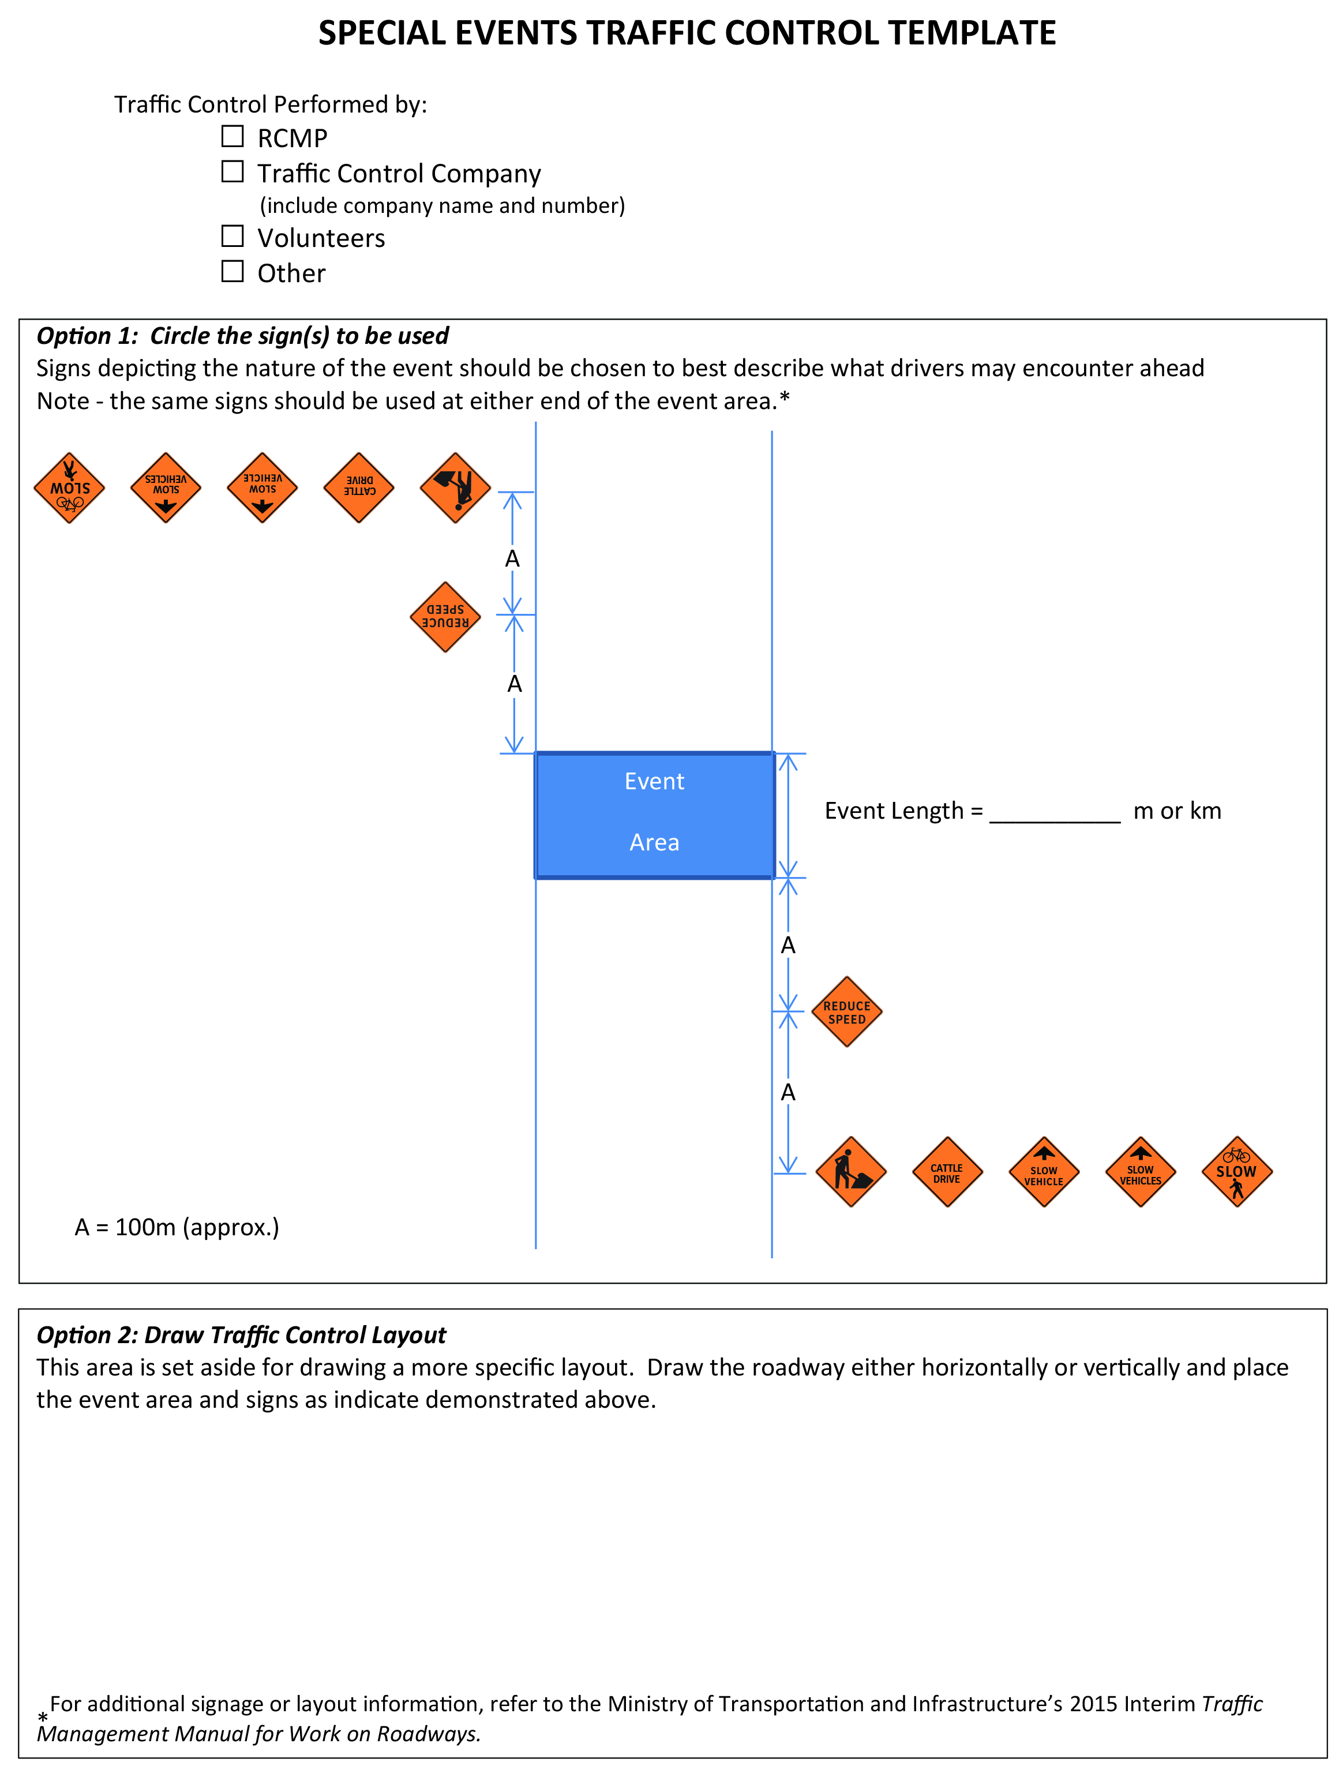
TRAFFIC OPERATIONAL REQUIREMENTS
The Permittee will comply with the following operational requirements:

SPECIAL EVENT INSURANCE CLAUSES
For copying and pasting into Section 16 of Form H0021-SE
LOW RISK EVENT REQUIRES:
LOW RISK EVENT REQUIRES:
- The Permittee must, without limiting its obligations or liabilities under this Permit, at its expense, maintain during the Term, Commercial General Liability Insurance, including non-owned automobile and contractual liability insurance with inclusive limits of not less than $2,000,000 for bodily injury, death or property damage arising from any one accident or occurrence. The insurance policy will indemnify the named insureds under the policy for all sums which the insured may become liable to pay or pays for bodily injury, death or property damage or for loss of use, arising out of or resulting under this Permit.
- “His Majesty the King in Right of the Province of British Columbia as represented by the Minister of Transportation and Transit” shall be added as an additional insured to the Commercial General Liability policy.
- If any licensed vehicles are owned, leased, rented or used in the performance of this contract, then Automobile Liability coverage with inclusive limits of not less than $2,000,000.00 providing third party liability and accident benefits insurance must be provided for all these vehicles.
- The Permittee will provide evidence of the required insurance only upon request by the Ministry by providing a compliant original signed certificate of insurance, duly executed by the authorized representative of the insurer.
MEDIUM RISK EVENT REQUIRES:
- The Permittee must, without limiting its obligations or liabilities under this Permit, at its expense, maintain during the Term, Commercial General Liability Insurance, including non-owned automobile and contractual liability insurance with inclusive limits of not less than $2,000,000 for bodily injury, death or property damage arising from any one accident or occurrence. The insurance policy will indemnify the named insureds under the policy for all sums which the insured may become liable to pay or pays for bodily injury, death or property damage or for loss of use, arising out of or resulting under this Permit.
- “His Majesty the King in Right of the Province of British Columbia as represented by the Minister of Transportation and Transit” shall be added as an additional insured to the Commercial General Liability policy.
- If any licensed vehicles are owned, leased, rented or used in the performance of this contract, then Automobile Liability coverage with inclusive limits of not less than $2,000,000.00 providing third party liability and accident benefits insurance must be provided for all these vehicles.
- Prior to the issuance of this Permit, the Permittee must deliver to the Designated Ministry Official evidence of the required insurance way of a compliant original signed certificate of insurance, duly executed by the authorized representative of the insurer. For Automobile Liability insurance ONLY, evidence may be provided on a duly executive I.C.B.C. APV47 or APB150L form. If any insurance policies expire during the Term of the Permit, evidence of renewal of the insurance coverage must be provided prior to the expiry date of the policy(s).
- Insurance requirements are as required by the Designated Ministry Official.

HIGH RISK EVENT REQUIRES:
- The Permittee must, without limiting its obligations or liabilities under this Permit, at its expense, maintain during the Term, Commercial General Liability Insurance, including non-owned automobile and contractual liability insurance with inclusive limits of not less than $5,000,000 for bodily injury, death or property damage arising from any one accident or occurrence. The insurance policy will indemnify the named insureds under the policy for all sums which the insured may become liable to pay or pays for bodily injury, death or property damage or for loss of use, arising out of or resulting under this Permit.
- The following clause is to be endorsed onto the policy(s):
Notwithstanding any other terms, conditions, or exclusions elsewhere in this policy, it is understood and agreed that this policy is extended to include insurance coverages and clauses as follows:
“His Majesty the King in Right of the Province of British Columbia as represented by the Minister of Transportation and Transit together with the employees, agents, and servants of the Minister,” hereinafter referred to as the Additional Named Insured, is added as an Additional Named Insured, in respect of Liability arising from the work or operations of the Insured and the Additional Named Insured, in connection with contracts entered in to between the Insured and the Additional Named Insured.
- If any licensed vehicles are owned, leased, rented or used in the performance of this contract, then Automobile Liability coverage with inclusive limits of not less than $2,000,000.00 providing third party liability and accident benefits insurance must be provided for all these vehicles.
- Prior to the issuance of this Permit, the Permittee must deliver to the Designated Ministry Official evidence of the required insurance by way of the completed Ministry of Transportation and Transit Certificate of Insurance (Form H0111), as attached to this Permit, duly executed by the authorized representative of the insurer. For Automobile Liability insurance ONLY, evidence may be provided either by a Ministry of Transportation and Transit Certificate of Insurance OR a duly executed I.C.B.C. APV47 or APB150L form. If any insurance policies expire during the Term of the Permit, evidence of renewal of the insurance coverage must be provided prior to the expiry date of the policy(s).
- Insurance requirements are as required by the Designated Ministry Official.
EXTREME RISK EVENT REQUIRES
Contact Insurance and Bonds Department

